**Lab: File path traversal, validation of start of path**

Problem: The application transmits the full file path via a request parameter, and validates that the supplied path starts with the expected folder

Goal:  retrieve the contents of the /etc/passwd file.

Solve:

1- /image?filename=/var/www/images/37.jpg

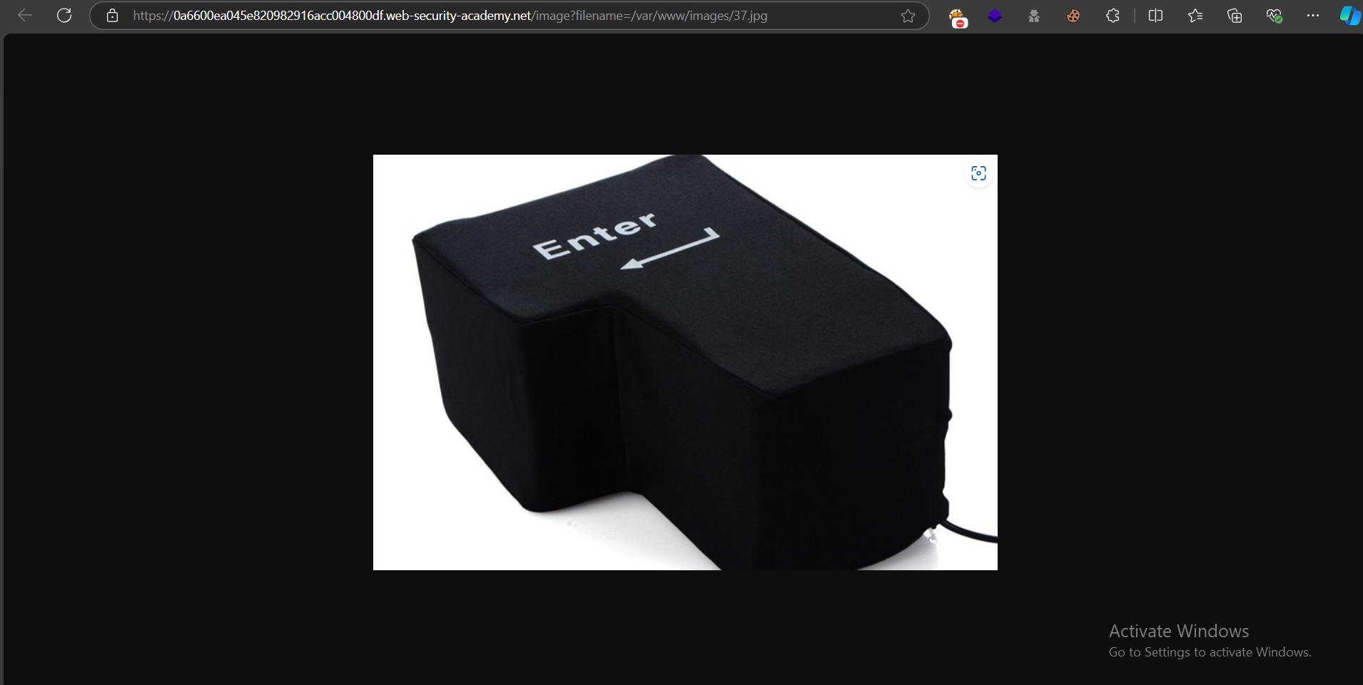



2-

**3-**

**4-**

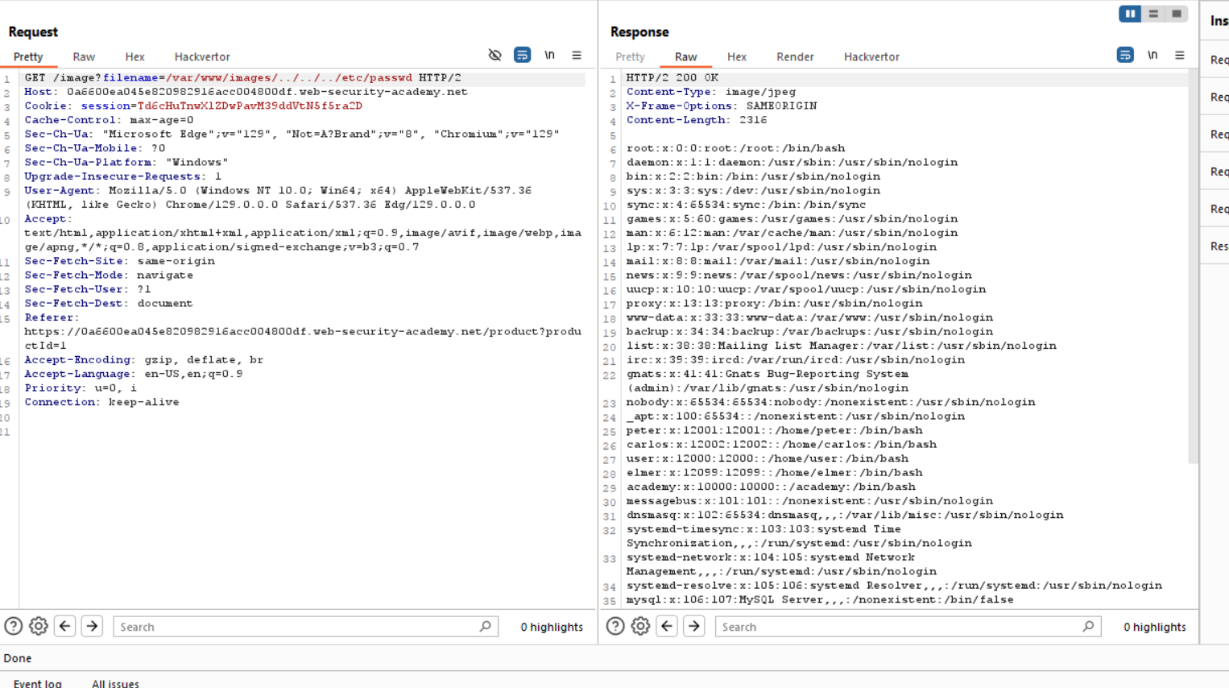

5- 